AutomationRule Test Analysis
Class under test: AutomationRule. JUnit tests go in AutomationRuleTest.java.
Note: AutomationRule has one method, evaluateEmergencyCoolingTrigger(SensorReading reading). It has seven decisions and no loops. Valid input: temperature −40 to 60 °C, humidity 0 to 100 %. Cooling triggers when T > 35, or when T ≥ 30 and H ≥ 80. Invalid input throws IllegalArgumentException; temperature is checked before humidity.

1. Control Flow Graphs
Node numbers: each statement or decision in the class gets one number. Start and End are not numbered. The two if statements use || and the return uses &&. Java stops at the first condition that decides the result (short-circuit), so each condition is drawn as its own decision node. The two throw statements (nodes 3 and 6) go to a separate Exception exit, as in the SmartHomeHub CFG; the returns go to End.
Node | Method | Statement
1 | evaluateEmergencyCoolingTrigger() | reading.getTemperatureCelsius() < -40.0 (decision)
2 | evaluateEmergencyCoolingTrigger() | reading.getTemperatureCelsius() > 60.0 (decision)
3 | evaluateEmergencyCoolingTrigger() | throw new IllegalArgumentException("Temperature out of acceptable bounds.")
4 | evaluateEmergencyCoolingTrigger() | reading.getHumidityPercentage() < 0.0 (decision)
5 | evaluateEmergencyCoolingTrigger() | reading.getHumidityPercentage() > 100.0 (decision)
6 | evaluateEmergencyCoolingTrigger() | throw new IllegalArgumentException("Humidity out of acceptable bounds.")
7 | evaluateEmergencyCoolingTrigger() | double temp = reading.getTemperatureCelsius()
8 | evaluateEmergencyCoolingTrigger() | double humidity = reading.getHumidityPercentage()
9 | evaluateEmergencyCoolingTrigger() | temp > 35.0 (decision)
10 | evaluateEmergencyCoolingTrigger() | return true
11 | evaluateEmergencyCoolingTrigger() | temp >= 30.0 (decision)
12 | evaluateEmergencyCoolingTrigger() | humidity >= 80.0 (decision)
13 | evaluateEmergencyCoolingTrigger() | return true
14 | evaluateEmergencyCoolingTrigger() | return false

evaluateEmergencyCoolingTrigger
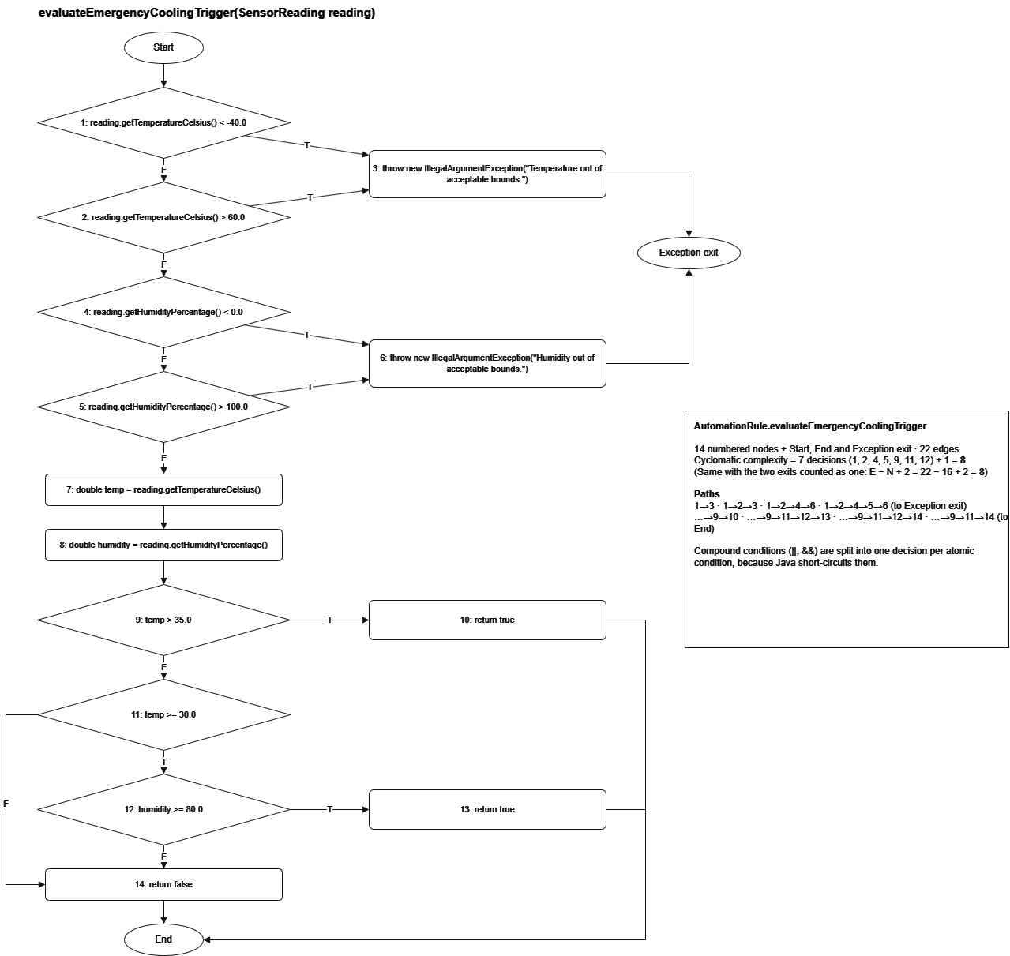

Test Cases
All structural test cases are listed once here. Each later section says which ones it uses. T = temperature (°C), H = humidity (%), IAE = IllegalArgumentException. The full ECP set (EC-01 to EC-20) and BVA sets (BVA-01 to BVA-23, WC-01 to WC-49) are listed in sections 7 and 8. A comma in a path means the test makes a second call.
ID | Input | Expected output | Path (nodes) | JUnit test
TC1 | T = −50, H = 50 | IAE (temperature) | 1→3 | p1_tempBelowMin
TC2 | T = 70, H = 50 | IAE (temperature) | 1→2→3 | p2_tempAboveMax
TC3 | T = 20, H = −10 | IAE (humidity) | 1→2→4→6 | p3_humBelowMin
TC4 | T = 20, H = 110 | IAE (humidity) | 1→2→4→5→6 | p4_humAboveMax
TC5 | T = 40, H = 10 | true | 1→2→4→5→7→8→9→10 | p5_tempAbove35
TC6 | T = 32, H = 90 | true | 1→2→4→5→7→8→9→11→12→13 | p6_hotAndHumid
TC7 | T = 32, H = 50 | false | 1→2→4→5→7→8→9→11→12→14 | p7_hotNotHumid
TC8 | T = 25, H = 90 | false | 1→2→4→5→7→8→9→11→14 | p8_notHot
TC9 | T = 32, H = 90, then T = 29, H = 90 | true, then false | 1→2→4→5→7→8→9→11→12→13, 1→2→4→5→7→8→9→11→14 | mcdc_tempIndependent
TC10 | T = 32, H = 90, then T = 32, H = 79 | true, then false | 1→2→4→5→7→8→9→11→12→13, 1→2→4→5→7→8→9→11→12→14 | mcdc_humidityIndependent
TC11 | T = 36, H = 50, then T = 35, H = 50 | true, then false | 1→2→4→5→7→8→9→10, 1→2→4→5→7→8→9→11→12→14 | mcdc_over35Independent
TC12 | T = +∞, then T = −∞ (H = 50) | IAE both times | 1→2→3, 1→3 | infinitiesRejected
TC13 | reading = null | An exception | Stops at node 1 (NullPointerException) | nullReadingRejected

2. Statement Coverage
Goal: run every node (1–14) at least once.
Test case | New nodes covered
TC1 | 1, 3
TC2 | 2
TC3 | 4, 6
TC4 | 5
TC5 | 7, 8, 9, 10
TC6 | 11, 12, 13
TC7 | 14

TC1–TC7 → 100% statement coverage.

3. Branch Coverage
Goal: take both the true (T) and false (F) edge of every decision (nodes 1, 2, 4, 5, 9, 11, 12).
Decision | True edge | False edge
1: T < −40 | TC1 | TC2
2: T > 60 | TC2 | TC3
4: H < 0 | TC3 | TC4
5: H > 100 | TC4 | TC5
9: temp > 35 | TC5 | TC6
11: temp ≥ 30 | TC6 | TC8
12: humidity ≥ 80 | TC6 | TC7

TC1–TC8 → 100% branch coverage. Because each || and && condition is its own node, this also gives full condition coverage.
MC/DC: each condition of the three compound decisions (the two || range checks and the &&) is shown to change the outcome on its own, with the other condition held fixed. temp > 35 is a single condition; it is listed for completeness.
Condition | Pair (only this condition changes) | Test case
temp ≥ 30 (in temp ≥ 30 && humidity ≥ 80) | (32, 90) → true vs. (29, 90) → false | TC9
humidity ≥ 80 (in temp ≥ 30 && humidity ≥ 80) | (32, 90) → true vs. (32, 79) → false | TC10
temp > 35 | (36, 50) → true vs. (35, 50) → false | TC11
T < −40 || T > 60 | −50 → throw, 70 → throw, 20 → continue | TC1, TC2, TC3
H < 0 || H > 100 | −10 → throw, 110 → throw, 50 → continue | TC3, TC4, TC5

4. Loop Coverage
Not applicable. The method contains no loops.

5. Path Coverage
Cyclomatic complexity = 7 decisions (nodes 1, 2, 4, 5, 9, 11, 12) + 1 = 8. The same result comes from E − N + 2 = 22 − 16 + 2 = 8 when the Exception exit and End are counted as one exit (14 nodes + Start + exit, 22 edges). The method has no loops, so it has exactly 8 paths, which are also its basis paths. Paths 1–4 end at the Exception exit; paths 5–8 end at End.
Path | Test case
1→3 | TC1
1→2→3 | TC2
1→2→4→6 | TC3
1→2→4→5→6 | TC4
1→2→4→5→7→8→9→10 | TC5
1→2→4→5→7→8→9→11→12→13 | TC6
1→2→4→5→7→8→9→11→12→14 | TC7
1→2→4→5→7→8→9→11→14 | TC8

All 8 paths covered → 100% path coverage.

6. Data-Flow Testing
Definitions and uses
Variable | Def (node) | C-use (node) | P-use (node)
reading (parameter) | Method start | 7, 8 | 1, 2, 4, 5
temp | 7 | — | 9, 11
humidity | 8 | — | 12

DU pairs (a p-use is covered on both its true and false edge)
Variable | DU pair | Covered by
reading | (start, 1) | TC1 (T), TC2 (F)
reading | (start, 2) | TC2 (T), TC3 (F)
reading | (start, 4) | TC3 (T), TC4 (F)
reading | (start, 5) | TC4 (T), TC5 (F)
reading | (start, 7), (start, 8) | TC5
temp | (7, 9) | TC5 (T), TC6 (F)
temp | (7, 11) | TC6 (T), TC8 (F)
humidity | (8, 12) | TC6 (T), TC7 (F)

All DU pairs covered (16 when each p-use edge is counted separately) → 100% all-uses coverage.

7. Equivalence Class Partitioning (ECP)
Variant: strong robust (from the testing plan). The classes are split at the decision thresholds 30, 35 and 80, not only at the valid-range edges. Every temperature class is combined with every humidity class: 5 × 4 = 20 test cases (EC-01 to EC-20).
Input | Class | Valid? | Representative value
Temperature | T1: below −40 | Invalid | −50
Temperature | T2: −40 to below 30 | Valid | 20
Temperature | T3: 30 to 35 | Valid | 32
Temperature | T4: above 35 to 60 | Valid | 45
Temperature | T5: above 60 | Invalid | 70
Humidity | H1: below 0 | Invalid | −10
Humidity | H2: 0 to below 80 | Valid | 50
Humidity | H3: 80 to 100 | Valid | 90
Humidity | H4: above 100 | Invalid | 110

Strong robust combinations (test case · expected output)
 | H1 (−10) | H2 (50) | H3 (90) | H4 (110)
T1 (−50) | EC-07 · IAE temp | EC-08 · IAE temp | EC-09 · IAE temp | EC-10 · IAE temp
T2 (20) | EC-15 · IAE hum | EC-01 · false | EC-02 · false | EC-18 · IAE hum
T3 (32) | EC-16 · IAE hum | EC-03 · false | EC-04 · true | EC-19 · IAE hum
T4 (45) | EC-17 · IAE hum | EC-05 · true | EC-06 · true | EC-20 · IAE hum
T5 (70) | EC-11 · IAE temp | EC-12 · IAE temp | EC-13 · IAE temp | EC-14 · IAE temp

For the SmartHomeHub analysis (TC11 and TC12): a reading that triggers cooling is T = 32, H = 90 (class T3 × H3, true); a normal reading is T = 25, H = 50 (class T2 × H2, false).

8. Boundary Value Analysis (BVA)
Variant: robust worst-case (from the testing plan), plus robust BVA on the internal decision thresholds. Step size: 0.01.

Robust worst-case BVA
Each input takes 7 values. Every temperature value is combined with every humidity value: 7 × 7 = 49 test cases (WC-01 to WC-49).
Value | Temperature | Humidity
min − 0.01 | −40.01 | −0.01
min | −40 | 0
min + 0.01 | −39.99 | 0.01
nominal | 10 | 50
max − 0.01 | 59.99 | 99.99
max | 60 | 100
max + 0.01 | 60.01 | 100.01

Temperature value | Expected over the 7 humidity values | Test cases
−40.01 | IAE (temperature) for all 7 | WC-01 to WC-07
−40, −39.99, 10 | H = −0.01 or 100.01 → IAE (humidity); otherwise false | WC-08 to WC-28
59.99, 60 | H = −0.01 or 100.01 → IAE (humidity); otherwise true | WC-29 to WC-42
60.01 | IAE (temperature) for all 7 | WC-43 to WC-49

Robust BVA on the decision thresholds
Worst-case BVA only uses the edges of the valid range, where no decision happens. The decisions are at 30, 35 and 80, so these are tested separately (BVA-01 to BVA-23; the rows below are the threshold cases).
Value | Meaning | Expected | Test case
T = 29.99 (H = 90) | just below 30 | false | BVA-05
T = 30 (H = 90) | at 30 | true | BVA-06
T = 30.01 (H = 90) | just above 30 | true | BVA-07
T = 34.99 (H = 50) | just below 35 | false | BVA-08
T = 35 (H = 50) | at 35 | false | BVA-09
T = 35.01 (H = 50) | just above 35 | true | BVA-10
H = 79.99 (T = 32) | just below 80 | false | BVA-15
H = 80 (T = 32) | at 80 | true | BVA-16
H = 80.01 (T = 32) | just above 80 | true | BVA-17
T = 30, H = 80 | both at threshold | true | BVA-18
T = 35, H = 79.99 | corner | false | BVA-19

9. Results and Coverage (planned vs. actual)
Test group | Tests | Pass | Fail
Strong robust ECP | 20 | 20 | 0
Robust BVA (edges and thresholds) | 23 | 23 | 0
Robust worst-case BVA | 49 | 49 | 0
Paths (TC1–TC8) | 8 | 8 | 0
MC/DC (TC9–TC11) | 3 | 3 | 0
Special values (TC12–TC13) | 2 | 2 | 0
Total | 105 | 105 | 0

Criterion | Planned | Actual
Statement | 100% | 100% (10/10 lines)
Branch | 100% | 100% (14/14 branches)
Loop | Not applicable | Not applicable
Path | 8/8 | 8/8
Data-flow (all-uses) | All DU pairs | All 16 covered
MC/DC | 3 compound decisions | 3/3
ECP (strong robust) | 20/20 combinations | 20/20
BVA (robust worst-case) | 49/49 | 49/49

Coverage measured with JaCoCo 0.8.13. Planned and actual coverage match.

Observations
NaN is not covered by the requirements; the range checks would not reject it.
A null reading throws NullPointerException at node 1 instead of IllegalArgumentException (TC13). The specification does not say which exception is expected.
When both inputs are invalid, only the temperature error is reported, because temperature is checked first (EC-07, EC-10, EC-11, EC-14).
The getters are called twice: in the range checks (nodes 1–5) and again at nodes 7–8. Not a bug, but redundant.

